How to create a clone in github step by step:

Step 1: Go to github and create a repository

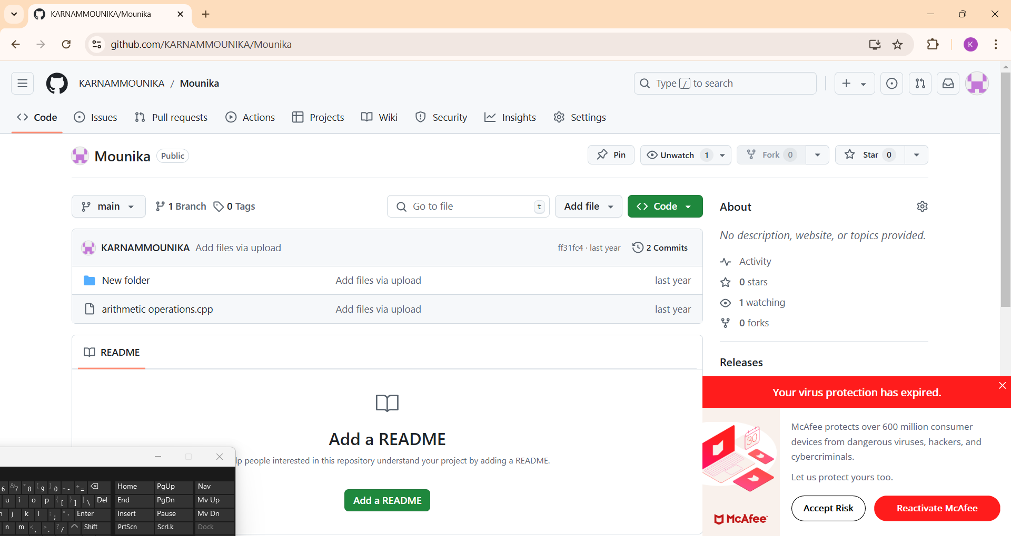

Step2: Click the code option

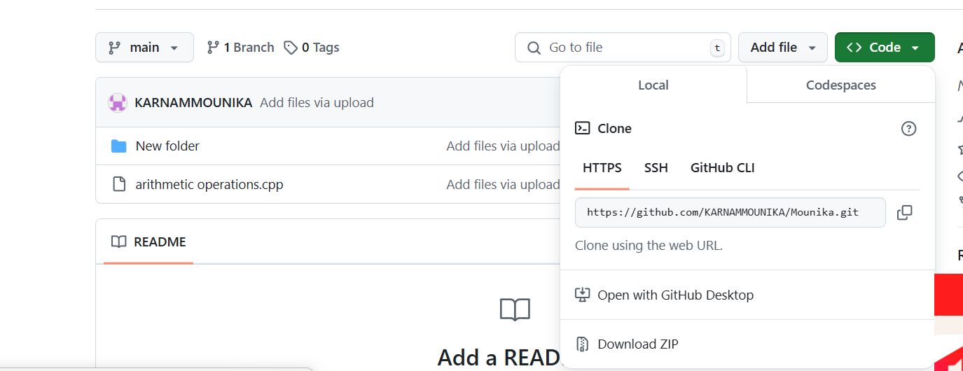

Step3: Copy the clone url

1.if you click the code it will show the options like https,SSH,Github

2.Copy the url of https

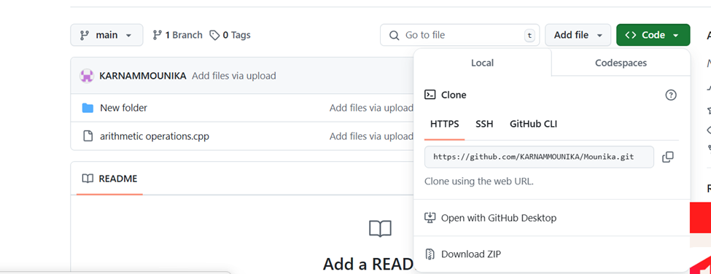

Step 4: Open your files

1.Open your files and create a new folder called sample

2.Download a Gitbash app

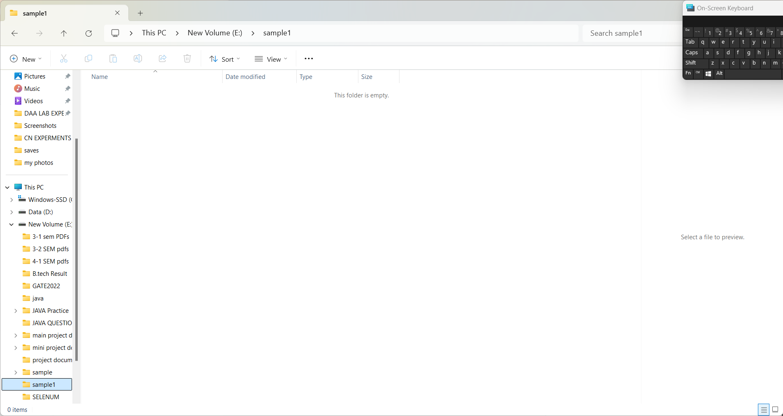

Step 5: Click on the sample 2

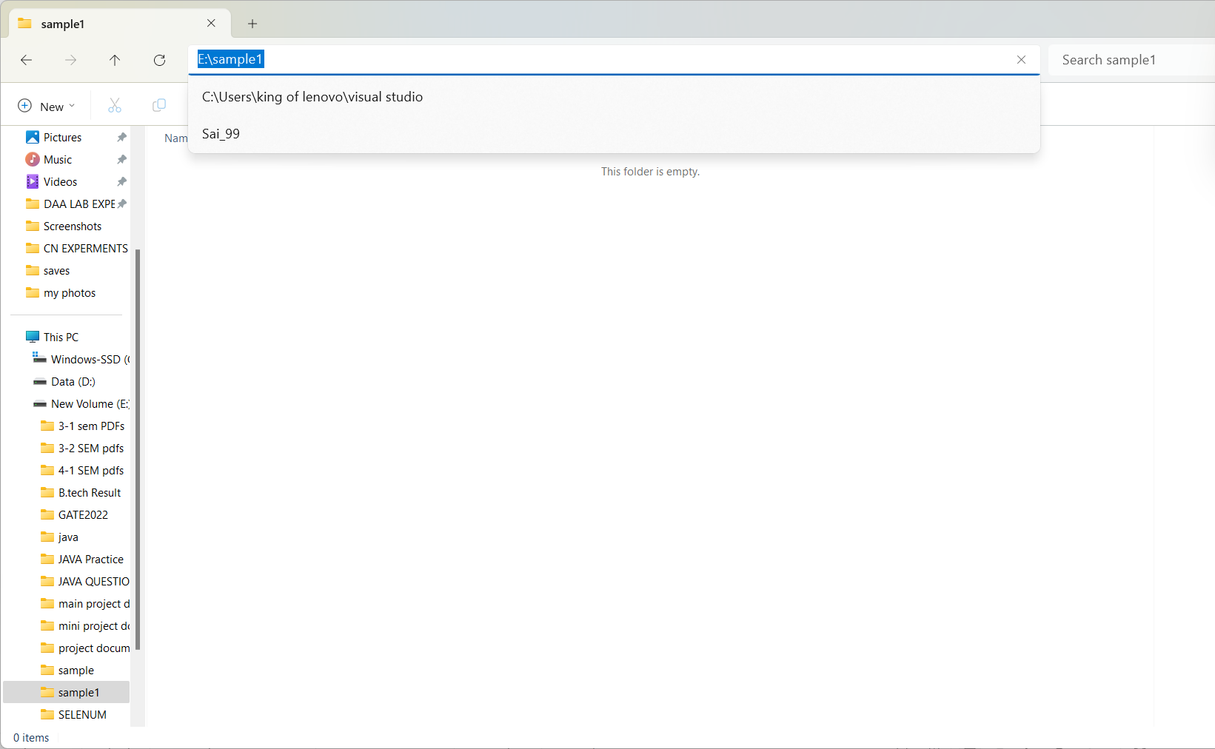

Step 6: Copy the C:\sample 2 and open the gitbash

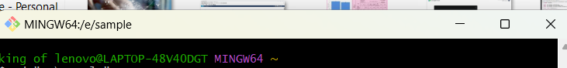

Step 7: Type cd and paste the sample 2 code “C:\sample 2” and press enter

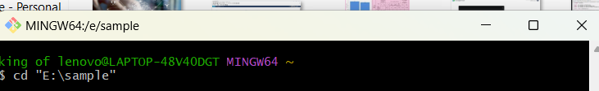

Step 8: Type git clone and paste the https code and press enter

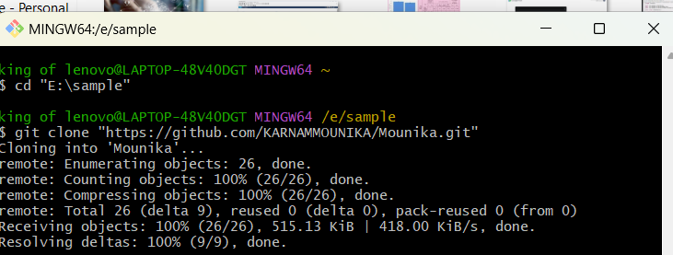

Step 9: Type ls



Step 10: Go the files and press sample 2

